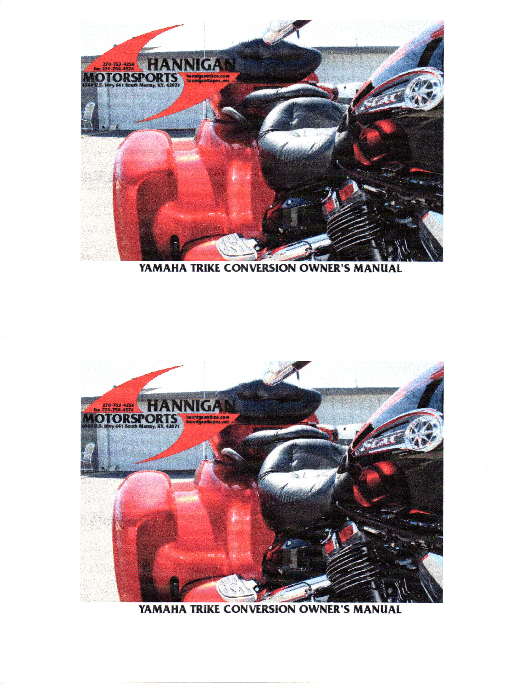FOR THE RIDE OF YOUR LIFE!

Congratulations on your selection of the Hannigan Trike. In an industry where some manufacturers compromise ride, and others compromise handling, we are proud of our no-compromise design. You have chosen a trike with a luxurious ride and sporty handling, which we hope meets all your expectations.

We consider the Hannigan Trike to be the ultimate Luxury-Performance Trike in the world today. We strive for safety, quality, comfort and perfection in our engineering construction and a commitment of onward dedication to our customers. We have created this owner’s manual to offer an insight and knowledge of your Trike. We recommend that you read this manual before operating your trike.

Please visit us on our web site:
www.hanniganmotorsports.com
Telephone: 270-753-4256
Fax: 270-759-4576
Email: hannigan@apex.net
Address: Hannigan Motorsports
4044 Hwy. 641 South
Murray, KY 42071

Index
Trike Riding Instructions

Maintenance

Electric Reverse (optional)

Auxiliary Fuel Tank (optional)

Tire/Wheel Removal

Parts/Components Replacement

Drive Line Components

Suspension

Wheel/Tire Information

Specifications

Warranty Policy

Trike Riding Instructions

Hannigan Motorsports recommends that you wear a helmet and protective gear at all times when riding, and that you complete a 3-wheel motorcycle skills training course. Passengers should also wear a helmet and gear.

- Before riding familiarize yourself with the location and use of all controls.

- Riders and passengers must keep their feet up on the foot pegs at all times when on the trike.
  - Failure to do so could result in serious injury.
  - Care should be taken not to kick the fenders when mounting the trike.

- Remember that trikes are wider at the rear.
  - Do not ride too close to people or obstacles.

- Steering on a trike is direct. You must turn the handlebar to point the front wheel in the direction you wish to travel.
  - Leaning your body or counter-steering will not work when steering a trike.
  - Use a push-pull technique to steer the trike. The pushing arm should have a locked elbow and upper body strength should be used rather than just the lower arms.
  - When executing sharp turns care must be taken not to roll on excessive throttle.
  - Riders should keep their head up and look in the direction they wish to travel. This is just as important in the parking lot as it is at road speeds.

- Low speed headshake may occur with any 3-wheel motorcycle configuration, especially on rough ground, and does not usually present any safety concerns.
  - If it occurs relax your grip on the bars. A tight grip will only amplify the effect.
  - Always keep both hands on the handlebars at all times, especially at lower speeds and when shifting up or down through the gears and when traveling on rough roads.

- Passengers should be advised what to expect on a trike.
  - A passenger may feel the centrifugal force to the outside of the corner which is a sensation not felt on a two wheel motorcycle but is common to trikes.
  - To overcome the centrifugal force they can brace their outside leg and lean into the corner a little without having an effect on the handling of the trike.

Hannigan Motorsports – For the Ride of Your Life

Maintenance

Body care
- The fiberglass body of the trike can be cleaned with a product that does not contain any abrasives or alcohol, and can be used on surfaces that are clear coated.
- Honda offers products that contain these types of formulas, as do other fine companies such as CycleCare 800-728-7800/ Cyclecare.com and Dri-Wash 800-422-3377/ Driwashsolutions.com.
- A spray & wash like Cycle Care 33 or Dry Wash may be used during the first 90 days.
- During this first 90 day period DO NOT use any kind of paste wax or polish of any kind that may seal the paint.
- The paint needs to breathe. We suggest you do not use at any time, a type of wax that will not allow the paint to breathe.

Covers
- Covers should not be left on for more than 24 hrs. when wet, clouding of the paint may occur.
- Covers should not be left on for long periods of time due to condensation between the cover and painted surfaces as this will also cloud the paint. Paint & fiberglass needs to breath.
- Transporting: Never cover a vehicle on open trailer, damage to paint will occur.

Wheels
- It is recommended you use products formulated for wheel cleaning/waxing that protects the clear coat on the wheel.

Rear End Differential
- Replace with 80/90-gear wt. oil every 2 years or 40,000 miles.
  - This replenishment of gear oil can be serviced at most lubrication shops by extracting the old oil with a siphoning air hose.
  - If you are checking the oil level, remove the metal threaded type which requires a square male end of a 3/8” socket extension.
  - The oil level should be approximately 1¹/₄” below the inspection hole.
  - The recommended 80/90-gear wt. oil can be used throughout all seasons of the year.

U-Joint
- New grease should be applied to this component every 15,000 miles.

Brake Fluid
- Refer to this item in your motorcycle owner’s manual.
  - The brake fluid type should be DOT 3 or DOT 4.
  - The brake fluid master cylinder reservoir is located just below the fuel tank on right side at the front.

Axles
- The left and right rear axles require no scheduled maintenance, as the lubricating grease is factory sealed inside the rubber boot attached to the axles.

Swing Arm Pivot
- Grease bearings every 30,000 miles.
  - With rear of bike raised on a jack check swing arms for lateral play.
  - If there is any perceptible play remove the dust cover cap at swing arm pivot.
  - Bend tab washer down and tighten the 1 ½ inch nut to 32 foot pounds.
  - Bend locking tab washer back up to ensure nut will not loosen. Re-install dust cap.

Trunk
- Check trunk door hinge screws every 10,000 miles.

*****Maintain motorcycle factory service schedule as found in motorcycle owner’s manual.****

REVERSE INSTRUCTIONS (OPTIONAL)

- Make sure bike is RUNNING and in NEUTRAL. (The reverse will only engage if in neutral)
- Check your surroundings and distances to obstacles to be sure there is no one or anything behind you. CAUTION! The reverse is powerful and quick.
- Flip the safety cover from the switch and press the reverse switch cautiously, (reverse is quick) either bump or hold the switch until you have backed up the desired amount. In close quarters we recommend bumping the switch. A jolt upon initial engagement is normal, thus bumping the switch is recommended until you are accustomed to how the reverse feels and functions.
- Once you have backed to the desired location, disengage the switch, replace the cover.
- To move forward, take the bike out of neutral and proceed with normal riding operations.
- Enjoy the ride.

NOTE: If during engagement the reverse repeatedly stutters while holding the switch the battery voltage is low. Reverse may not engage properly if the battery is low. Check battery.

Auxiliary Fuel Tank (Optional)

- The auxiliary fuel tank filler cap is on a chain, so be careful not to scratch paint when removing the cap.
- The auxiliary fuel tank is a transfer tank.
  - Before using the tank be sure you have used at least ¾ of the main fuel in the main tank.
  - With the motorcycle running transfer fuel by turning on the fuel pump switch.
  - The fuel will transfer in 6 to 10 minutes.
  - After this time be sure and switch fuel pump off.
  - Failure to turn the switch off could burn the pump out.

Tire/Wheel Removal

It is recommended a scissors jack with a “closed” clearance of approximately 4 ½” be purchased.
This type of jack can be purchased at most popular auto parts/accessories stores for about $20.00 and have lift capacity rating of about 2,000 lbs. or more. A small hydraulic floor jack also works great.

Rear Tire/Wheel Removal & Reinstallation
- Be sure the surface under the trike is flat and sufficiently hard to support the weight of the jack and the trike.
- Place the transmission out of neutral and into gear to prevent the trike from rolling. Place the jack under the rear differential and use this as the jacking point.
- Before lifting with the jack, loosen slightly the lug nuts.
- Begin jacking the trike until sufficient clearance is obtained, so center stand can be put down.
- Remove the wheel/tire assembly.
- Re-install the wheel/tire assembly,
- Hand-tighten the lug nuts strongly.
- Slowly lower the jack until it no longer supports the vehicle.
- Fully tighten the lug nuts with a torque wrench to 80 ft lbs.

Parts/Components Replacement Information

Brake Components
- The rotors and calipers are Brembo.
- Brake Pads can be purchased at Hannigan Motorsports, or through your local motorcycle dealer
(part# EBC FA266HH)
- The remaining associated brake components (steering knuckles/hubs and the tie-
rod ends) are parts from a Honda Civic CRX from 1984 through and including
1987.

Drive Axles
- The drive axles are custom made for Hannigan Motorsports.
  - The outer CV Joint is from a Honda Civic automobile.
  - The inner CV Joint is from a Ford Thunderbird 1989-1997.
  - Removal of Drive axles can be accomplished by removing wheel, undoing shock, sway bar, and removing swing arm.

Drive Line Components

- Venture uses original Yamaha drive shaft.
- Differential Universal is 1990 Ford Thunderbird
- Ford Thunderbird 7.5” rear end with independent drive shafts.

Suspension

- Front Forks:
- The front forks utilize stock springs.

- Rear Suspension
- Trikes use Progressive Suspension. I.A.S. shocks with a standard progressive spring rate of 200/350.
- There are 5 settings of preload on the springs.
- Springs will require several hundred miles of break in and may ride stiff until fully broke in.
- A C-wrench is used for adjusting spring preload. This must be done with bike jacked up and no weight on shocks. Attempting to adjust preload without motorcycle jacked up can result in damage to the shock and is not covered under warranty.

Wheel / Tire Info

- The wheels on the Yamaha Venture are a 4 x 100 bolt pattern with 38 mm offset.
  - 15” x 7” (pre 2012) Mag wheels with Kumho radial tires.
  - 16” x 7” (2012 & UP) Mag wheels with Kumho radial tires.

Tire Air Pressure Tire Size If you live in an area where the roads have a high
Front – 41-42 psi. crown, the tendency of the Trike to follow the slope of
Rear – 28 psi. Pre 2012 195/60 R15 the road to the right may be countered by reducing
2012 & up 195/55 R16 the left rear tire pressure to 26 psi.

- Wider than standard wheels or tires or wheels with a different offset could result in
clearance problems.
- The above recommended tire air pressures are suitable for all load conditions.
  - When replacing either rear tire, we recommend radial tires of the same brand (Kumho) and size. In all cases, rear tires should be a matched set.

Specifications

- Weight: Approximately 320 lbs. (Represents only the extra-added conversion weight to the motorcycle).
- You must add the weight of the motorcycle (see your motorcycle owner’s manual) with the 320 lbs. to obtain the entire (gross) weight of the trike.

Width: 61.5”
Length: 112”
Wheelbase: 74”
Track: 51"

Limited Warranty - Hannigan Motorsports Trikes, Tri-cars.
(Valid only in the USA and Canada)

Hannigan Fairing Co. Ltd, DBA Hannigan Motorsports, warrants each Hannigan Trike to be free of defects in materials and workmanship for a period of two (2) years for unlimited mileage, commencing with the date the unit is delivered to its first retail purchaser. If the unit is resold during the warranty period, the balance of the warranty is transferable. This warranty is applicable only to Trikes manufactured by Hannigan Motorsports, and does not extend to the motorcycle to which such units may be attached.
This limited warranty applies to parts and labor only. No other warranty is expressed or implied. Hannigan Motorsports excludes incidental and consequential damages, including towing or hauling, loss of time, inconvenience, or loss of use of the vehicle.
To obtain service under this warranty, the unit must be delivered, upon discovery of the defect, to the Hannigan Motorsports factory in Murray, Kentucky, or to an authorized Hannigan dealer. The factory or dealer will, without charge for parts or labor, either repair or replace the defective part(s) using new or authorized remanufactured parts. The decision to repair or replace said part(s) is solely the prerogative of Hannigan Motorsports. Parts for which replacements are made become the property of Hannigan Motorsports.
In the event that it is not feasible to deliver the defective unit to the Hannigan Motorsports factory or to an authorized Hannigan dealer, Hannigan Motorsports may authorize the repair to be done at a qualified motorcycle repair facility. Any such repair must be authorized by the Hannigan Motorsports factory before the work is performed. Payment for labor will be based on the flat rate established by the factory.
This warranty does not apply to the following:
- maintenance services (such as lubrication, wheel balancing, mechanical adjustments)
- service and wear items (such as brake pads)
- failure to service
- damage caused by accident, abuse, or neglect

There is NO International Warranty! Hannigan Motorsports is not responsible for import/export related laws, duties, taxes or other fees.

Hannigan Motorsports reminds you to ride safely and wear a helmet and protective gear.

Web site: www.hanniganmotorsports.com
Email: hannigan@apex.net
Telephone: 270-753-4256
Address: 4044 U.S. Hwy. 641 S.
Murray, KY 42071

